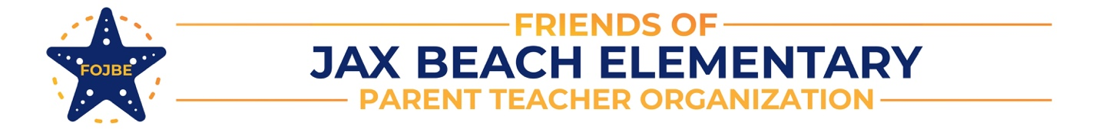

Favorites

Name:

Monogram:

Color: Sports Teams:

Snacks:

Restaurants (sit down & fast food):

Favorite Place for a quick/takeout lunch:

Teacher supplies/supply store:

Grocery Store:

Drink (coffee/tea/soda):

Smoothie Flavor:

Bookstore:

Collectible:

Department Store:

Hobbies:

Do you enjoy homemade foods as gifts? Yes or No

Do you have any dietary considerations (allergies, preferences)?

Your idea of being pampered:

Anything else you would like to share:

